Report: Laboratory work 8

**Tracking and forecasting in conditions of measurement gaps**

Team #1: Viktor Liviniuk, Alina Liviniuk

During this laboratory work the estimation and tracking algorithm in conditions of measurement gaps was develop. It is of prime importance for many practical control and forecasting problems.

Trajectory, measurements with gaps were generated, then Kalman filtration algorithm was improved for gaps and implied for gap probability P = 0.2:

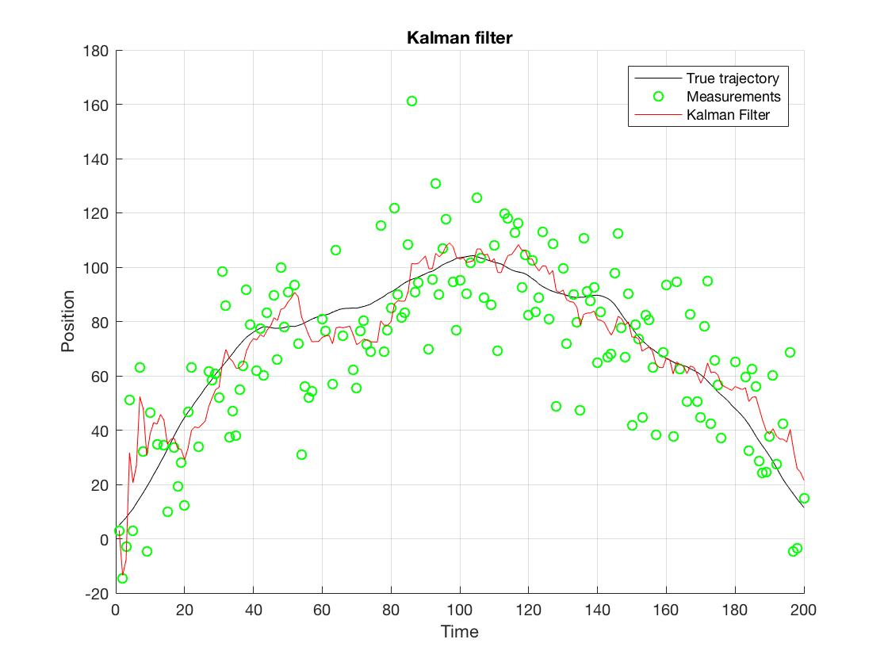

After 500 runs of filter (gap probability P = 0.2), filtered and extrapolated errors of estimation (1 step and 7 steps ahead) were determined. The next plot shows comparison of true estimation errors with errors of methods:

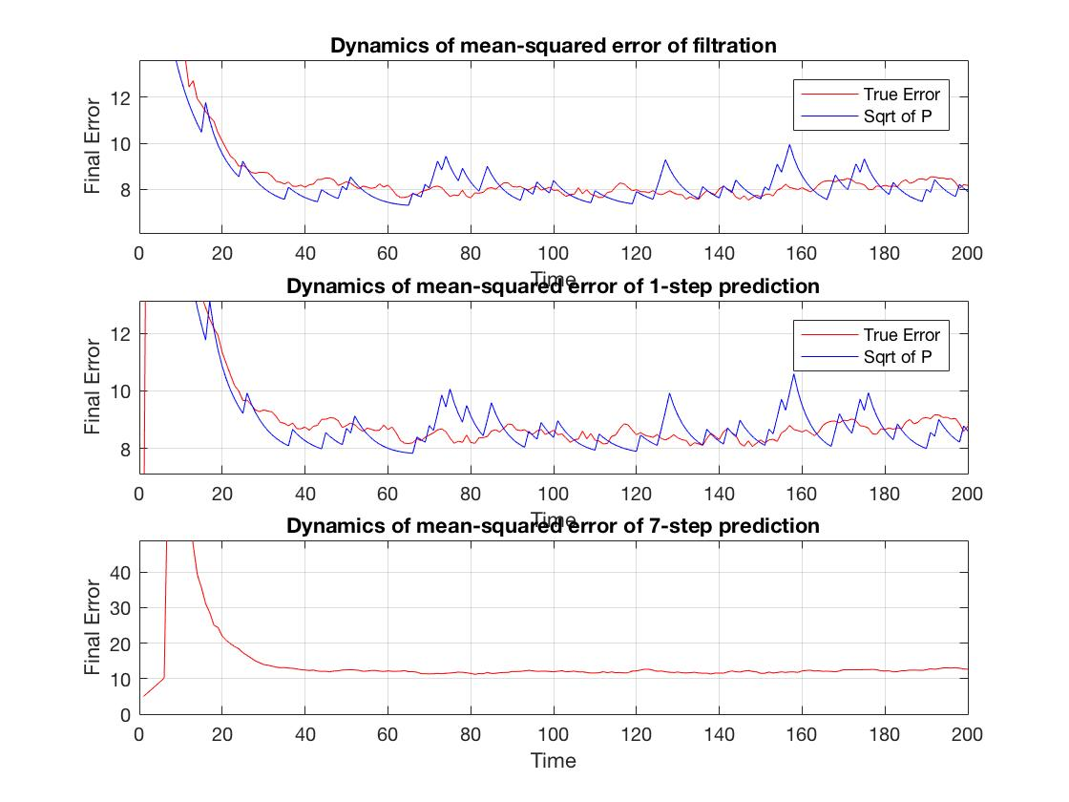

True estimation error corresponds to calculation errors of estimation (same with prediction).

Two more sets of data were collected to analyze the decrease of estimation accuracy in conditions of measurement gaps.

1. Results with gap probability P = 0.3:

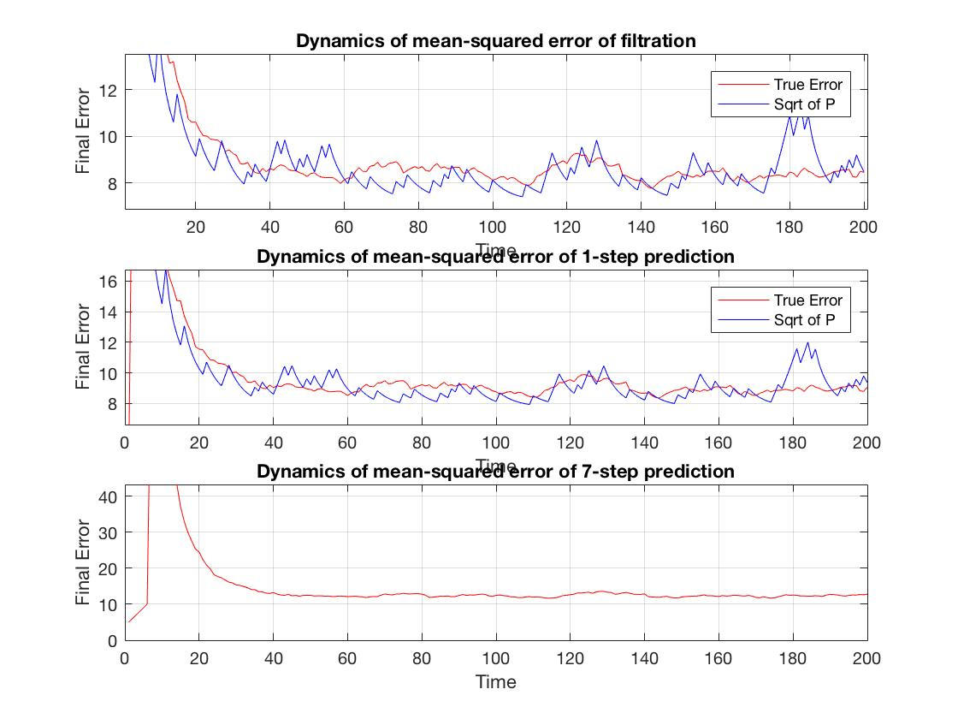

1. Results with gap probability P = 0.5:

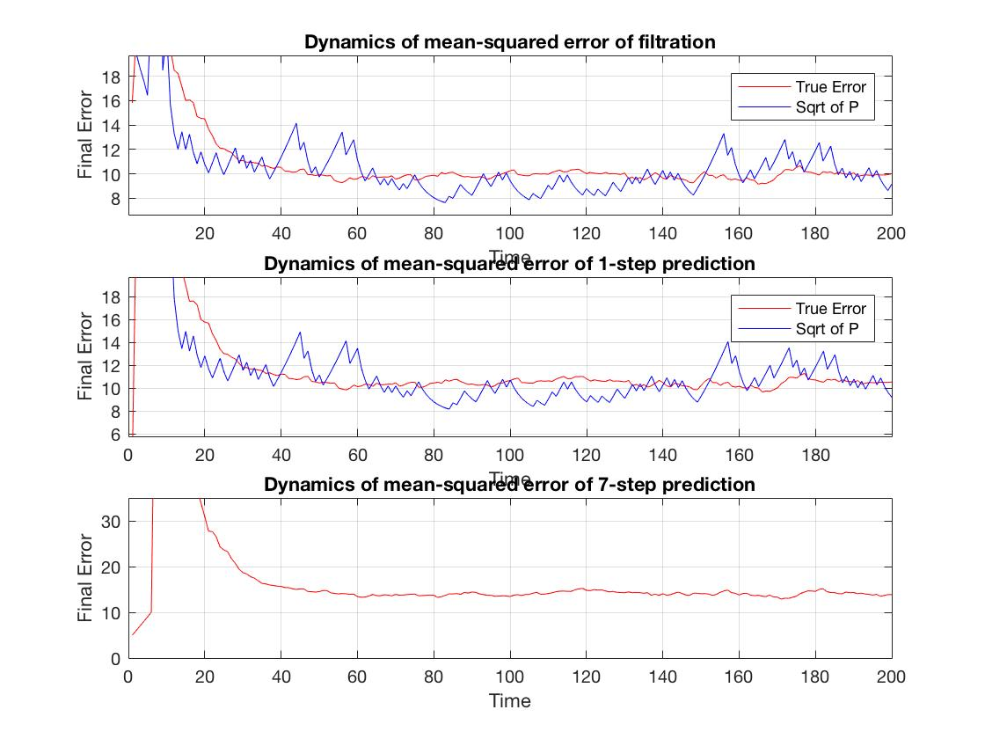

When gap probability increased from .3 to .5, final error of filtration increased from 8.5 to 10. Final error of 1-step prediction increased from 9 to 10.5. Error of 7-step prediction increased from 12 to 15.

**Conclusion**

Modified Kalman filter algorithm works well even with measurement gaps. However, the accuracy depends on the frequency of gaps and decreases as measurement gaps become more probable.

Files with matlab code are attached.